John Titor time machine manual and pics

http://anomalies.net/time_travel/john.html

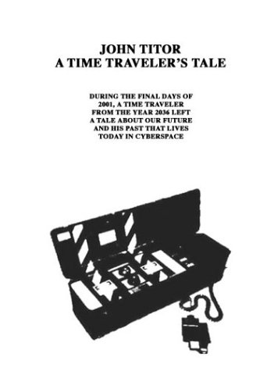

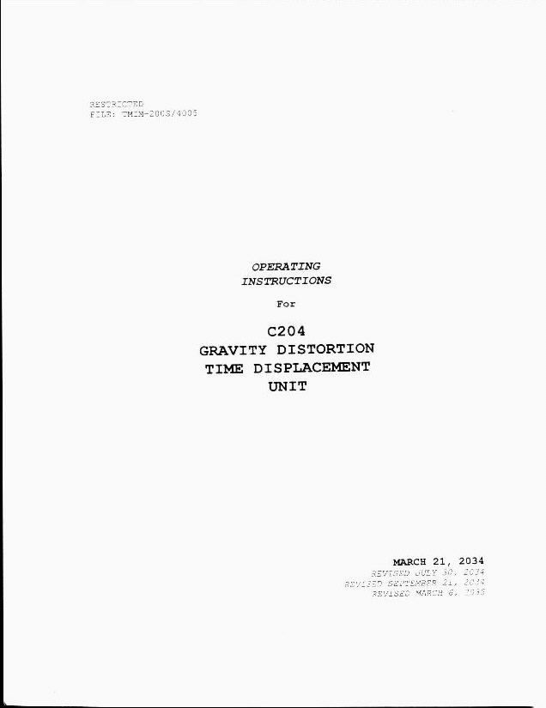

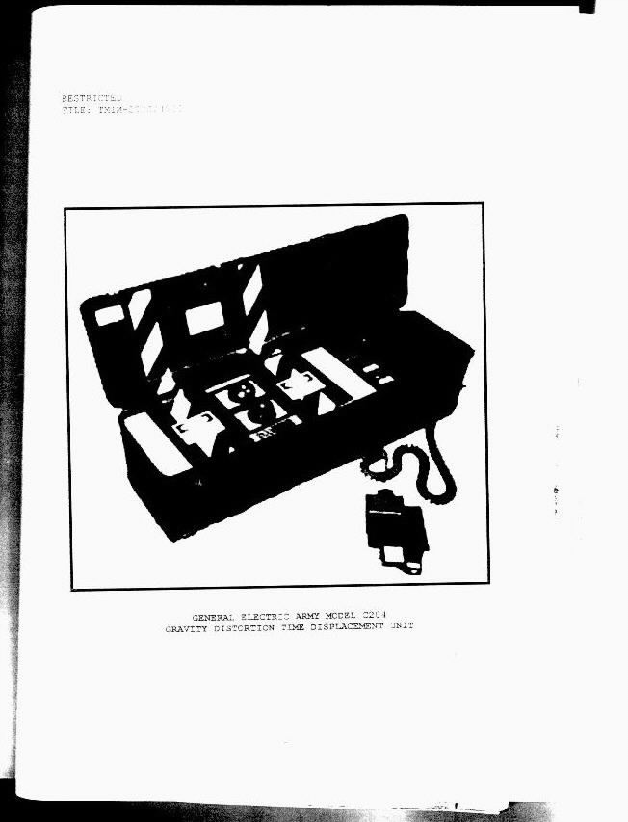

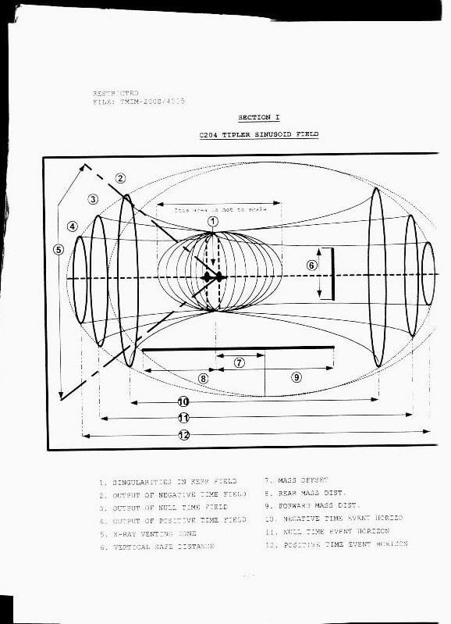

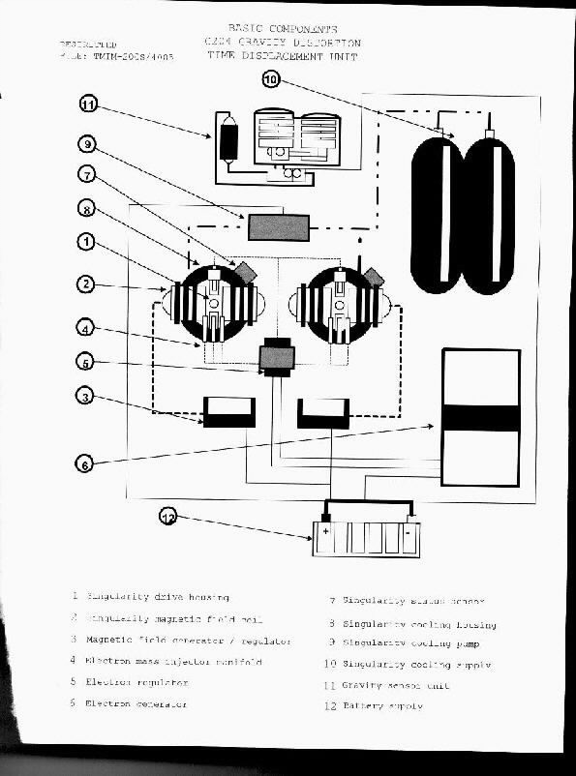

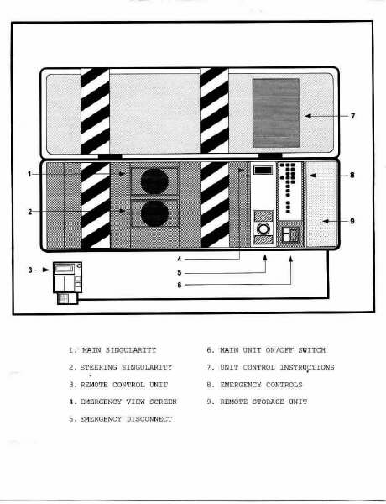

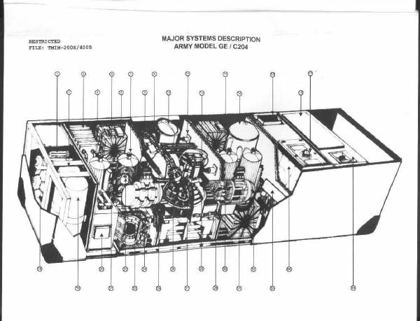

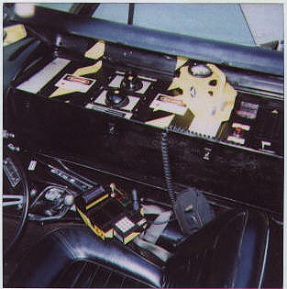 Image of the Time Travel Unit

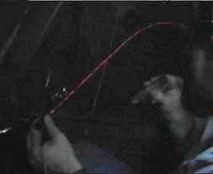

This is a picture taken in the fall of 2035 during my training. It shows my instructor beaming a handheld laser outside the vehicle during operation. The beam is being bent by the gravitational field produced outside the vehicle by the distortion unit. The beam is visible through smoke that is coming from his cigar.

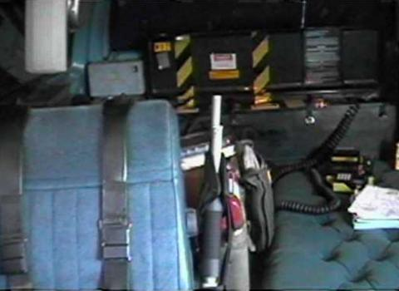

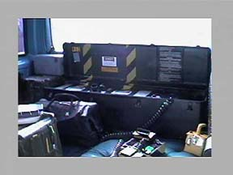

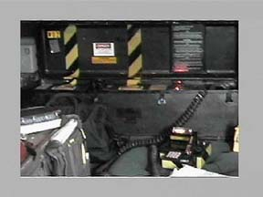

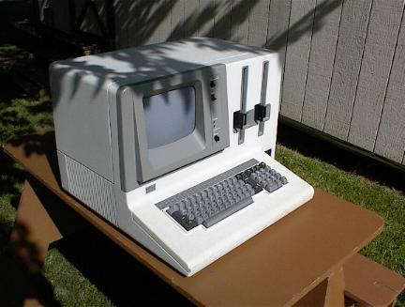

This is the same model of computer John took back to the future. Its an IBM Series 5100, type 5110 (Thanks Pamela for the images)

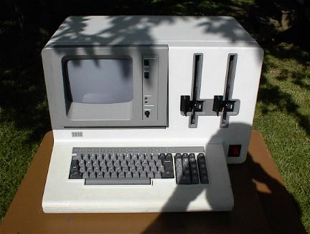

same machine different angle.

